1. man command-line  
   Like a -help: man cp, will show you all cp -options
2. ls -a:   
   list all files which includes hidden files.

ls -l:

List files in long form, includes more files details  
  
Ls -lah  
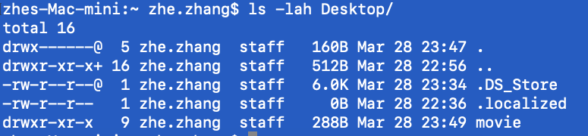

1. 1 “.” means current directory  
   2 “.” means previous/parent directory  
   cd ../.. : means go up 2 layer of the directory  
   cd ~: go to home directory directly.
2. open file_name:  
   Open a file in a default app from OS.
3. cp original_file_name new_file_name  
   Copy file
4. mv original_file_name new_file_name  
   Rename to a new file name  
   mv original_directory new_directory  
   Rename a directory
5. mv original_file_name directory_name  
   Move the file to the new directory location  
   Mv original_directory/ new_directory/  
   Move original_directory under new_directory
6. mv original_file_name directory_name/new_file_name  
   Move the file to the new directory location with the new file name(rename)
7. cp -R directory_1 directory_2:  
   Copy directory_1 to directory_2
8. rm file_name  
   rm -R directory_name  
   Deleve directory need -R as option  
   rm -rf directroy_name  
   Forced to delete directory
9. find directory_name:  
   Final everything under the directory_name  
     
   find directory_name -type d  
   Find all directory under directory_name  
     
   find directory_name -type f  
   Find all files under directory_name  
     
   find directory_name -type f -name “test*”  
   Use * as wildcard to search file name.   
     
   find directory_name -size +5M  
   Find files with more than 5MB
10. history:  
    Show you all of the historical commend lines.
11. ! (any characters)  
    Find all of your historical commend lines which contains the characters you key in.
12. Cat /directory/file_name  
    Show the file content
13. grep “any characters” files_name  
    Search “any characters” in the file_name (broad search)  
    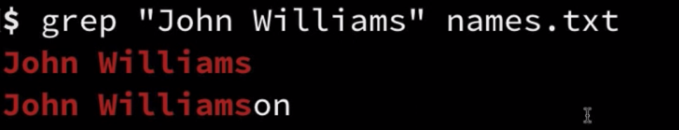  
      
    grep -w “any characters” files_name (exact search)  
      
    grep -wi “any characters” files_name (exact search)  
    Return the records with no case sensitive  
      
    grep -win “any characters” files_name (exact search)  
    Return the records with the line #  
    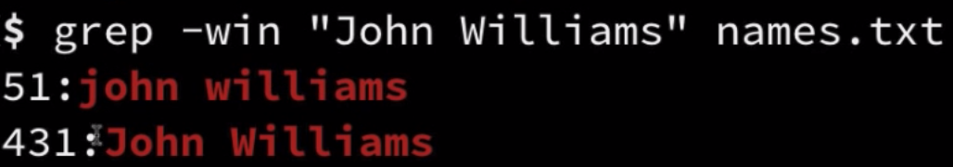  
    grep -win “jay zhang” directory/*.txt  
    Search the “jay zhang” from all txt file under directory  
      
    grep -winr “jay zhang” directory/  
    Recursive search all of “jay zhang” under directory  
    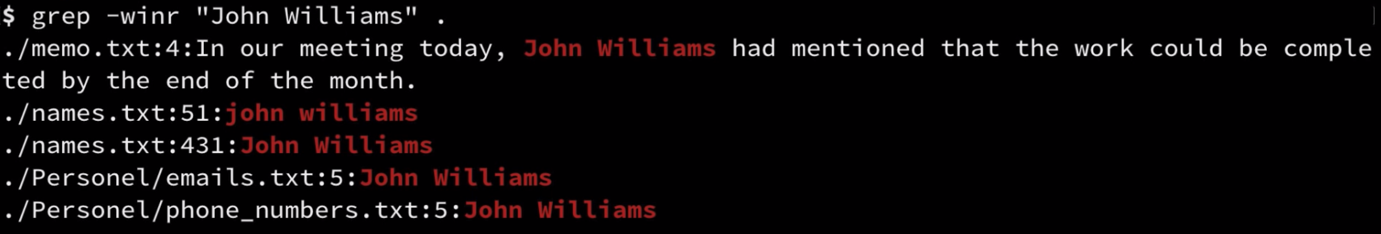  
    grep -wirl “jay zhang” directory/  
    Recursive search all of “jay zhang” under directory, and only return the filename which contain the match.  
    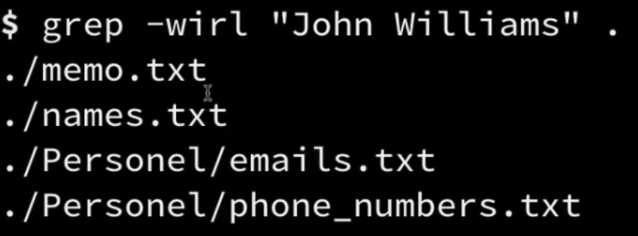  
    **grep “jay zhang” | grep “git commit”  
    Pipe the grep can combine multiple search keywords**  
    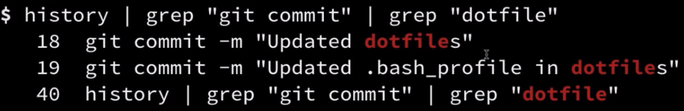  
    grep “...-...-....” file_name  
    Regular expression search on file_name  
    

**Keyboard Shortcut:**

1. Ctrl + a: jump to the beginning of the command line.
2. Ctrl + e: jump to the end of the command line.
3. Alt + 左右：move one word at a time
4. Ctrl + u: delete all characters before the mouse cursor
5. Ctrl + k: delete all characters after the mouse cursor
6. cd + drag the folder  
   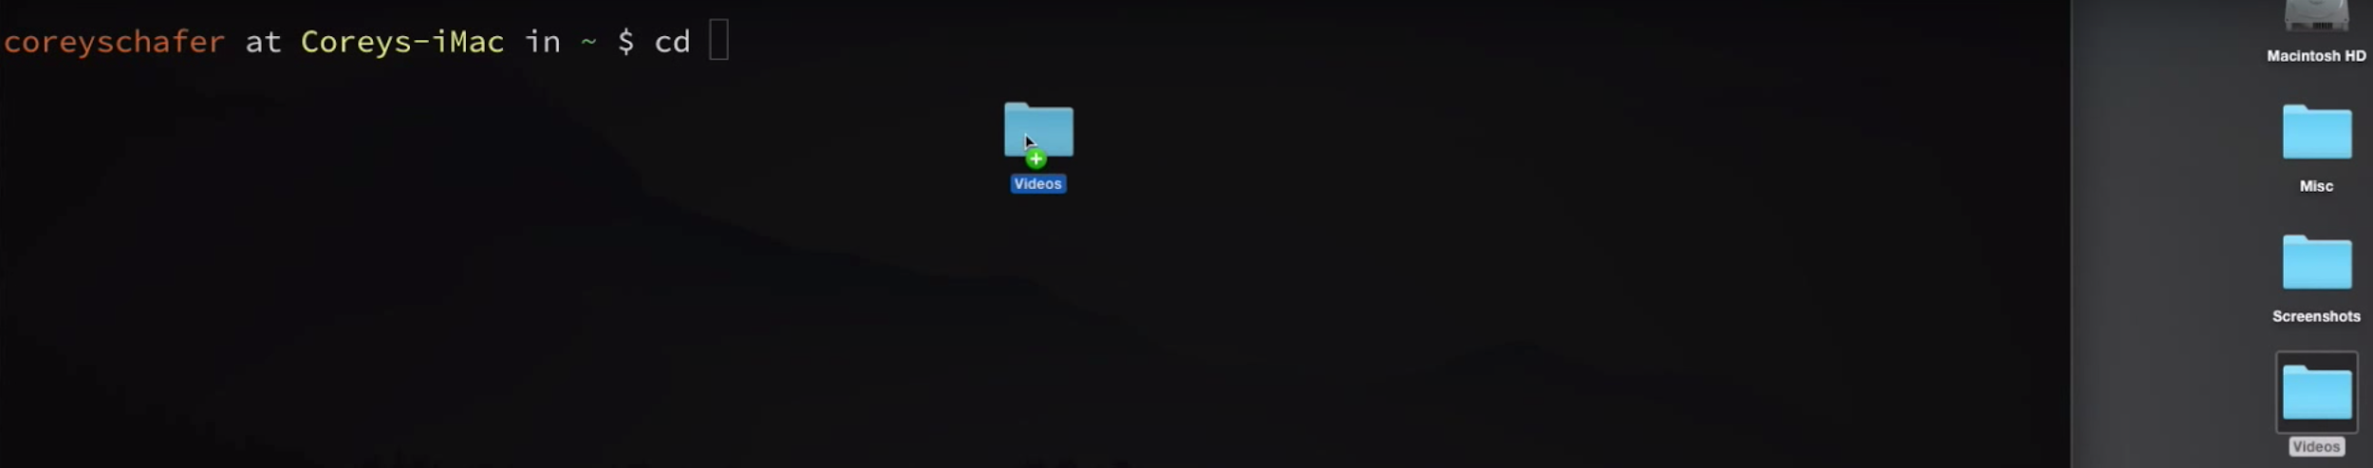  
   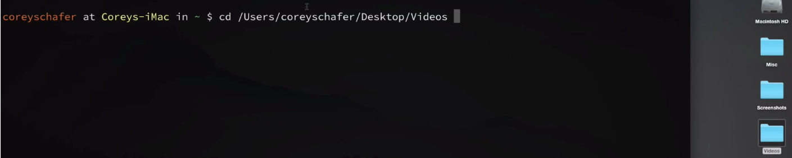
7. Ctrl + r  
   Interactively reverse search the command line you have used.
8. Ctrl + l = clear  
   Clean up the screen, but keep the historical records when you scroll up.
9. Cmd+k   
   Clean up the screen and no historical records will be kept.

**Crontab**

1. crontab -l  
   List ALL current crontab jobs.
2. crontab -e  
   Will open a default editor for your to update the cron job
3. crontab -r  
   Remove the crontab

**System setup:**

1. sudo nano /etc/paths  
   Then edit/update the paths
2. Echo $PATH  
   Show ALL current active paths